

1. DES / 3DES Code:
#include <stdio.h>
#include <string.h>

#define KEY 0x5A

// Encryption
void encrypt(char text[])
{
int i;

for(i = 0; text[i] != '\0'; i++)
{
text[i] = text[i] ^ KEY;
}
}

// Decryption
void decrypt(char text[])
{
int i;

for(i = 0; text[i] != '\0'; i++)
{
text[i] = text[i] ^ KEY;
}
}

int main()
{
char plaintext[100];

printf("Enter Plain Text: ");
fgets(plaintext, sizeof(plaintext), stdin);

// Remove newline
plaintext[strcspn(plaintext, "\n")] = '\0';

encrypt(plaintext);

printf("\nEncrypted Text : ");
printf("%s", plaintext);

decrypt(plaintext);

printf("\nDecrypted Text : ");
printf("%s", plaintext);

return 0;
}
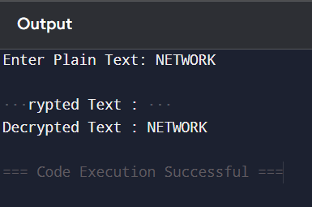

2. AES Block Cipher Modes:
#include <stdio.h>
#include <stdlib.h>
#include <string.h>
#include <time.h>

#define BLOCK_SIZE 8

// PKCS#7 Padding
int addPadding(unsigned char *input, int len) {
int pad = BLOCK_SIZE - (len % BLOCK_SIZE);
for (int i = 0; i < pad; i++)
input[len + i] = pad;
return len + pad;
}

// Remove Padding
int removePadding(unsigned char *input, int len) {
int pad = input[len - 1];
return len - pad;
}

// XOR Function
void xorBlock(unsigned char *a, unsigned char *b, unsigned char *out) {
for (int i = 0; i < BLOCK_SIZE; i++)
out[i] = a[i] ^ b[i];
}

// Dummy Encryption (Replace with DES if needed)
void encryptBlock(unsigned char *block, unsigned char *key) {
for (int i = 0; i < BLOCK_SIZE; i++)
block[i] ^= key[i];
}

// Dummy Decryption
void decryptBlock(unsigned char *block, unsigned char *key) {
for (int i = 0; i < BLOCK_SIZE; i++)
block[i] ^= key[i];
}

int main() {

unsigned char key[BLOCK_SIZE] = "SECURE12";
unsigned char iv[BLOCK_SIZE];

srand(time(NULL));

printf("Generated IV: ");
for(int i=0;i<BLOCK_SIZE;i++){
iv[i]=rand()%256;
printf("%02X ",iv[i]);
}

printf("\n");

unsigned char plaintext[100]="Network Security Lab";
int len=strlen((char *)plaintext);

len=addPadding(plaintext,len);

unsigned char previous[BLOCK_SIZE];
memcpy(previous,iv,BLOCK_SIZE);

printf("\nCiphertext:\n");

for(int i=0;i<len;i+=BLOCK_SIZE){

unsigned char block[BLOCK_SIZE];

xorBlock(&plaintext[i],previous,block);

encryptBlock(block,key);

memcpy(previous,block,BLOCK_SIZE);

for(int j=0;j<BLOCK_SIZE;j++)
printf("%02X ",block[j]);

}

printf("\n");

return 0;
}
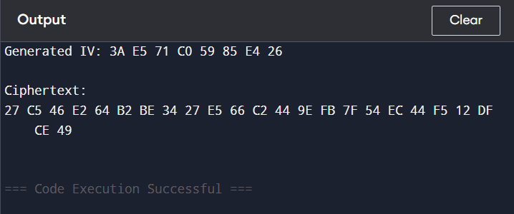

3.RSA Cryptosystem Implementation:
#include <stdio.h>

// Function to calculate (base^exp) % mod
long long modExp(long long base, long long exp, long long mod)
{
long long result = 1;
base = base % mod;

while (exp > 0)
{
if (exp % 2 == 1)
result = (result * base) % mod;

exp = exp / 2;
base = (base * base) % mod;
}

return result;
}

// Function to find GCD
int gcd(int a, int b)
{
while (b != 0)
{
int t = b;
b = a % b;
a = t;
}
return a;
}

int main()
{
long long p = 17, q = 11;
long long n = p * q;
long long phi = (p - 1) * (q - 1);

long long e = 7;
while (gcd(e, phi) != 1)
e++;

long long d;

for (d = 1; (d * e) % phi != 1; d++);

printf("Public Key (e,n): (%lld,%lld)\n", e, n);
printf("Private Key (d,n): (%lld,%lld)\n", d, n);

long long message;
printf("\nEnter message (number < %lld): ", n);
scanf("%lld", &message);

long long cipher = modExp(message, e, n);
printf("Encrypted Message = %lld\n", cipher);

long long plain = modExp(cipher, d, n);
printf("Decrypted Message = %lld\n", plain);

return 0;
}
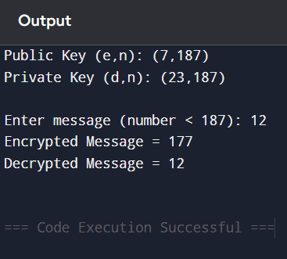

4.Diffie–Hellman Key Exchange:
#include <stdio.h>

// Fast Modular Exponentiation
long long modExp(long long base, long long exp, long long mod)
{
long long result = 1;
base = base % mod;

while (exp > 0)
{
if (exp % 2 == 1)
result = (result * base) % mod;

base = (base * base) % mod;
exp = exp / 2;
}

return result;
}

int main()
{
long long p, g;
long long a, b;
long long A, B;
long long keyA, keyB;

printf("Enter Prime Number (p): ");
scanf("%lld", &p);

printf("Enter Primitive Root (g): ");
scanf("%lld", &g);

printf("Enter Private Key of User A: ");
scanf("%lld", &a);

printf("Enter Private Key of User B: ");
scanf("%lld", &b);

// Public Keys
A = modExp(g, a, p);
B = modExp(g, b, p);

printf("\nPublic Key of User A = %lld\n", A);
printf("Public Key of User B = %lld\n", B);

// Shared Secret Keys
keyA = modExp(B, a, p);
keyB = modExp(A, b, p);

printf("\nShared Secret Key (User A) = %lld\n", keyA);
printf("Shared Secret Key (User B) = %lld\n", keyB);

if (keyA == keyB)
printf("\nKey Exchange Successful!\n");
else
printf("\nKey Exchange Failed!\n");

return 0;
}
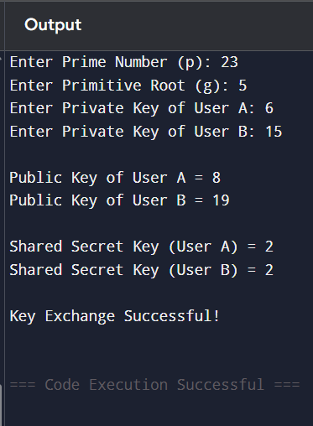

5.Elliptic Curve Cryptography:
#include <stdio.h>

// Structure to represent a point
typedef struct {
int x, y;
} Point;

// Point at Infinity
Point INF = {-1, -1};

// Point Addition (Simplified for Demonstration)
Point pointAdd(Point P, Point Q)
{
Point R;

if (P.x == -1) return Q;
if (Q.x == -1) return P;

R.x = (P.x + Q.x) % 17;
R.y = (P.y + Q.y) % 17;

return R;
}

// Double-and-Add Scalar Multiplication
Point scalarMultiply(Point P, int k)
{
Point result = INF;

while (k > 0)
{
if (k % 2 == 1)
result = pointAdd(result, P);

P = pointAdd(P, P); // Point Doubling
k = k / 2;
}

return result;
}

int main()
{
Point G;
int k;

printf("Enter Base Point (x y): ");
scanf("%d %d", &G.x, &G.y);

printf("Enter Scalar (k): ");
scanf("%d", &k);

Point R = scalarMultiply(G, k);

printf("\nResult after Scalar Multiplication:\n");
printf("(%d, %d)\n", R.x, R.y);

return 0;
}
